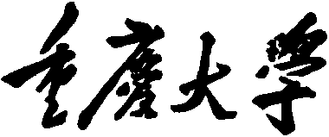


Personal Learning Portfolio

Course： English Academic Writing Teacher： Zhang Mei
Class： 001 Major：计算机科学与技术
Name： 陈秦 Student Number： 20204220
Class Time： 2022.9-2023.1
Grade：2020

Self | Teaching Assistant | Teacher
陈秦 | 曾钰婷 | 张梅

Comments：

Teacher (Signature)
Contents
Week 1
- My learning
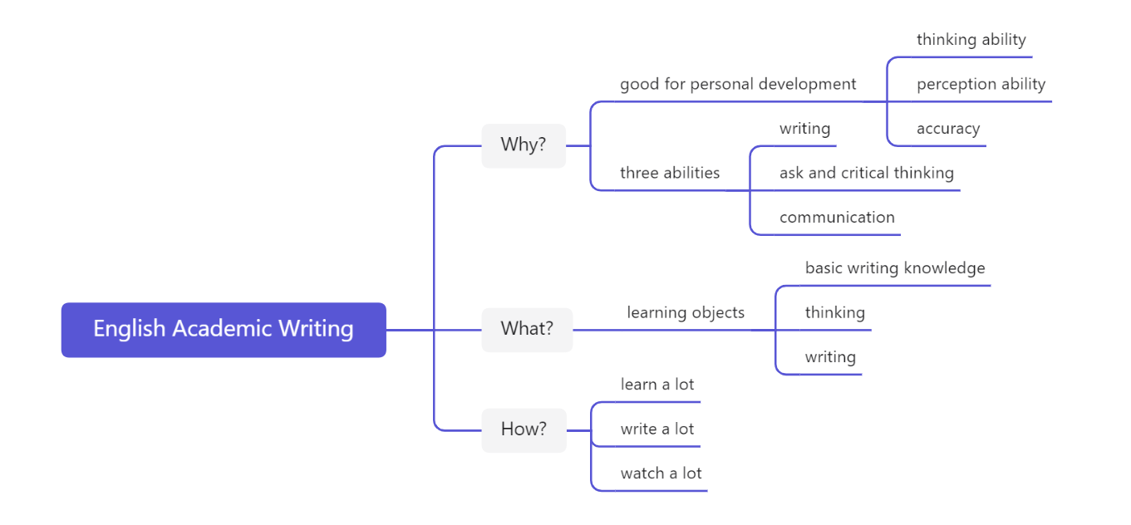
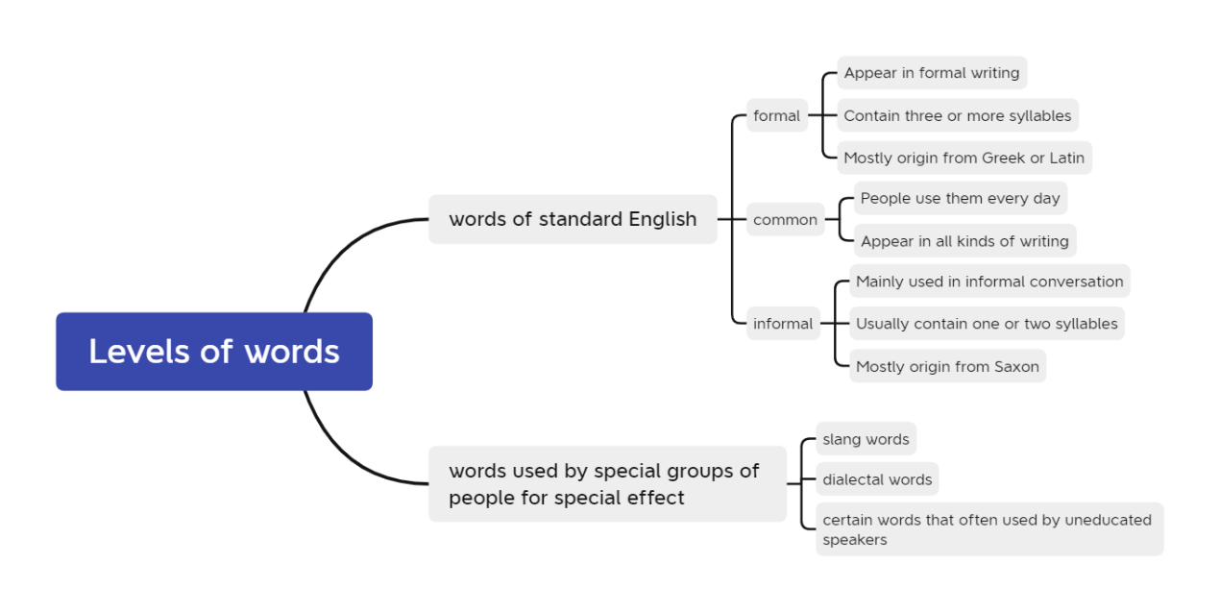
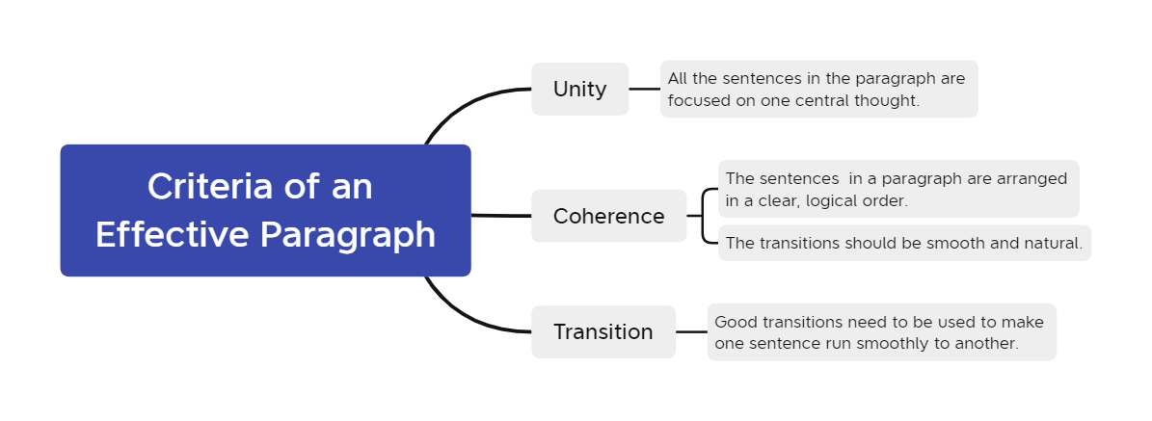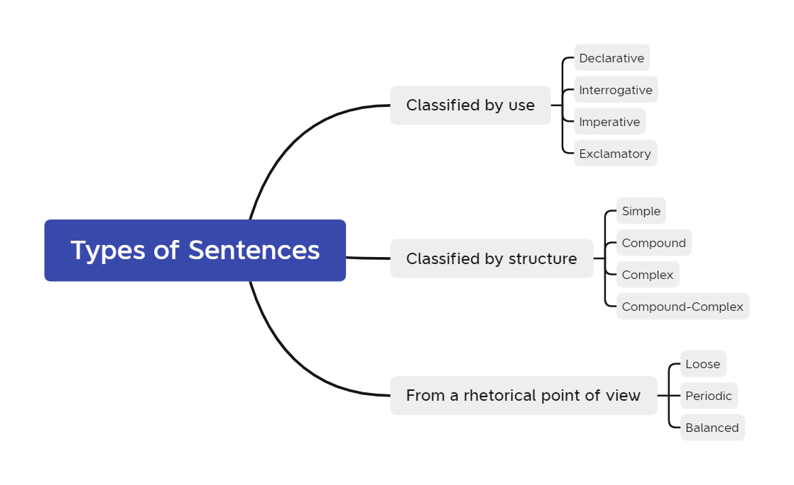
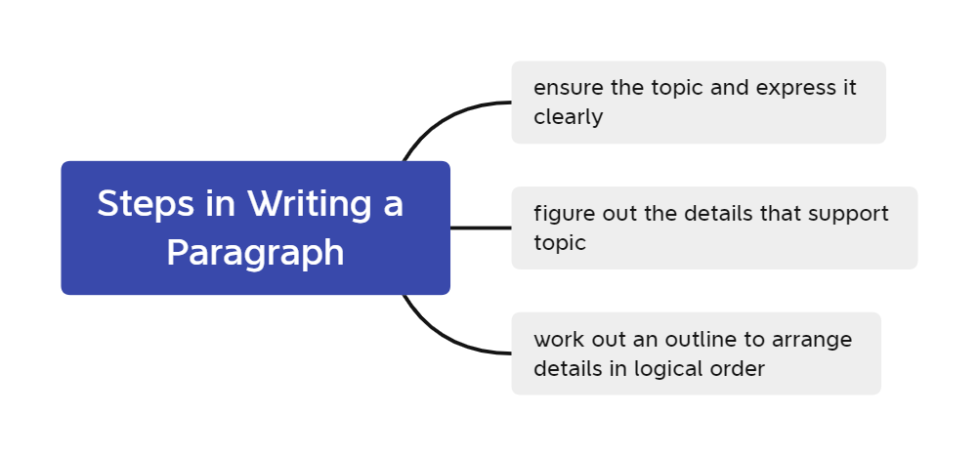
- Learning outcome
Write an academic essay.
Give a speech to convey my point of view.
By learning these points, I understands that I should ensure the topic when writing an article. Then I must think of the details to support the topic. During this process, I need to notice that the use of words and sentences. In the end, I can work out an outline to arrange the details in a logic order. When I begin to write the article, the unity, coherence and transitions of article are also important.
- My behavior and attitude
1）Out of Class
1.1 Autonomous learning（Online + Offline）
I carefully read the English essay writing manual given by the teacher and summarized some issues that we need to pay attention to in the writing process. Through this work, I believe that I can avoid making some mistakes that cannot be ignored in the writing of my paper.
1.2 Homework
Complete the homework carefully, think carefully about the resaerch methodology parts, and complete them carefully. And submit it in time, without waiting until the deadline to finish.
2)In class
After listening carefully to the teacher's requirements for learning reports, I have a clearer understanding. I can answer questions from the teacher positively.
4．Improvement
This time I have a preliminary understanding of English essay writing, from the use of words, the writing of sentences, to the organization of paragraphs, to a comprehensive understanding of the order and precautions of English essay writing. This makes me, a thesis white, also confident that I can complete the writing of the thesis independently through my own study.

Week 2
- My learning
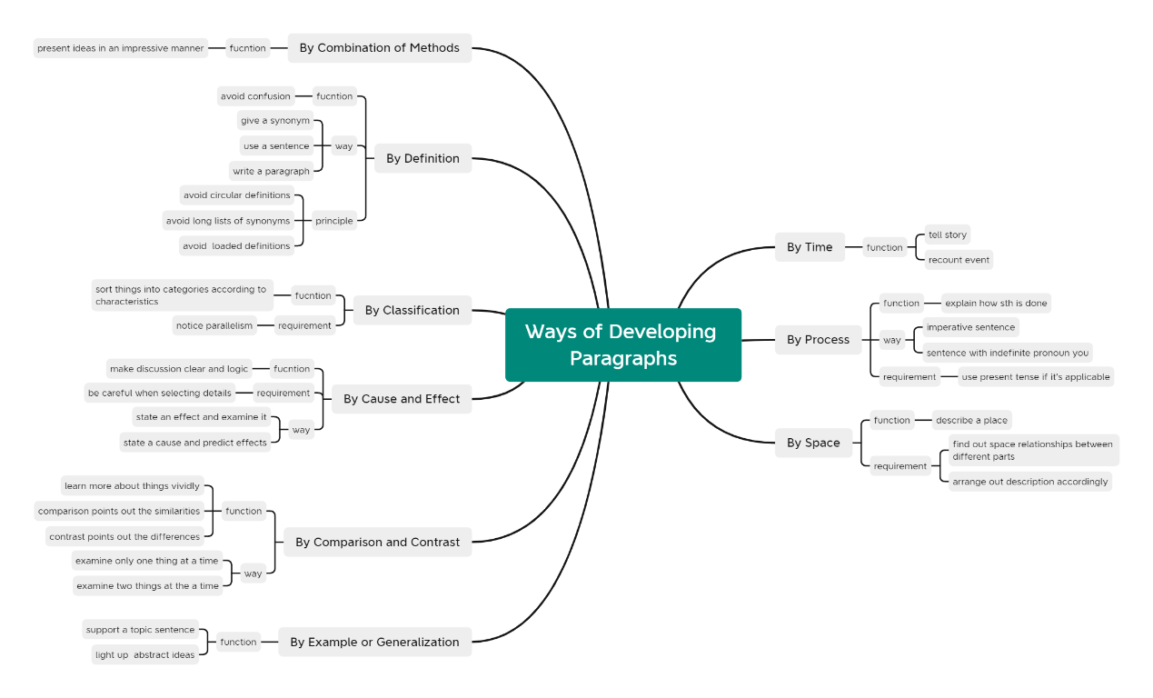
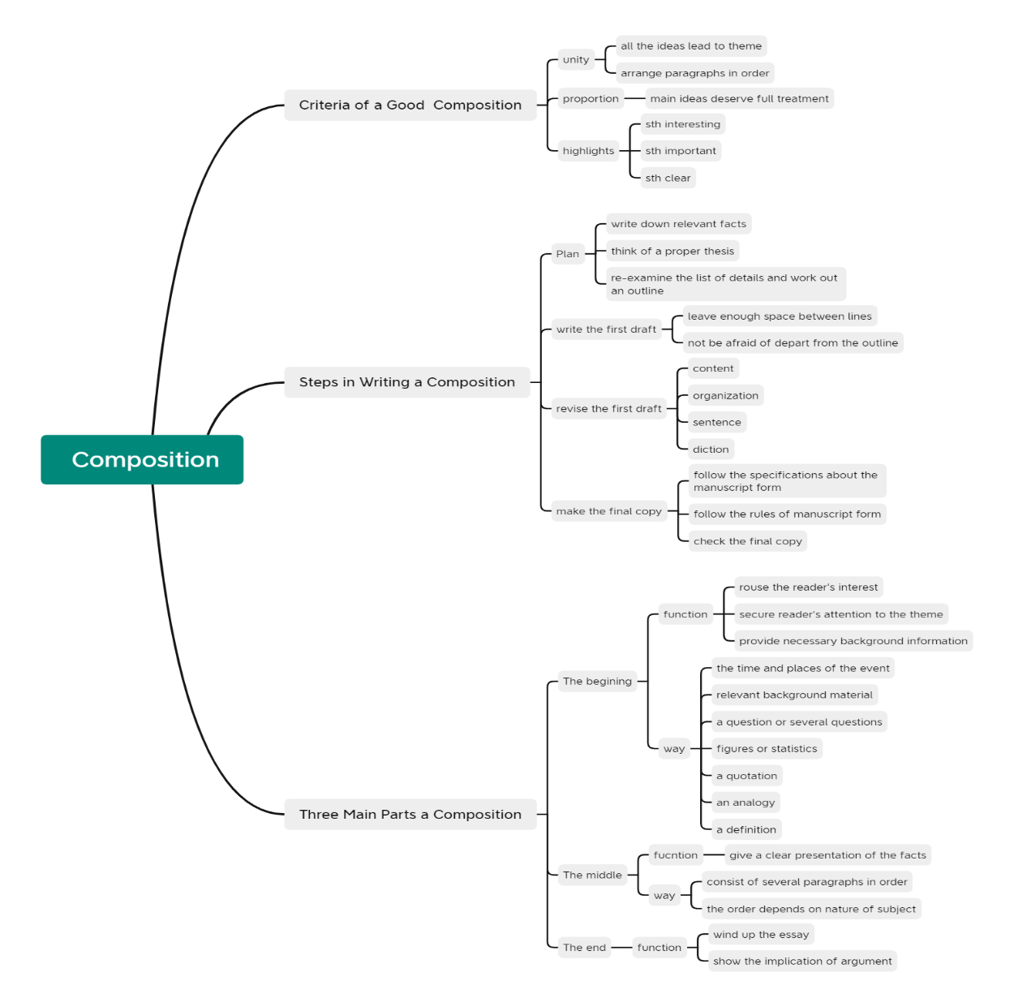
- Learning outcome
(1). When we develop a paragraph, there are nine ways that we can choose. Sometimes we may choose one or more of them in the same paragraph. It’s necessary for us to notice the manner we use them to make the paragraph impressive and logical.
(2). We need to learn about it that some ways of developing paragraphs have their own criteria. For example, the comparison points out the similarities of different ideas and contrast points out differences.
(3). In every process of creating a composition, check is important. For instance, we ought to notice whether most of the paragraphs of composition lead to the theme and they are arranged in a suitable order.
(4). The four steps listed in writing a composition are indispensable. All of them together can lead to a perfect outcome.
- My behavior and attitude
1）Out of Class
1.1 Autonomous learning（Online + Offline）
I carefully read the English essay writing manual given by the teacher and summarized some issues that we need to pay attention to in the writing process. Through this work, I believe that I can avoid making some mistakes that cannot be ignored in the writing of my paper.
1.2 Homework
Complete the homework carefully, think carefully about the resaerch methodology parts, and complete them carefully. And submit it in time, without waiting until the deadline to finish.
2)In class
After listening carefully to the teacher's requirements for learning reports, I have a clearer understanding. I can answer questions from the teacher positively.

4．Improvement
During the writing process, I paid careful attention to the language, sentences, and grammar problems in the process of writing the paper, and recorded them in the form of a mind map. Trust that no mistakes will be made during the essay writing process.

Week 3
- My learning
In class:
Development way:
1. Development by time
2. Development by process
3. Development by space
4. Development by example
5. Development by comparison and contrast
6. Development by cause and effect
7. Development by classification
8. Development by definition
9. Development by a combination of methods
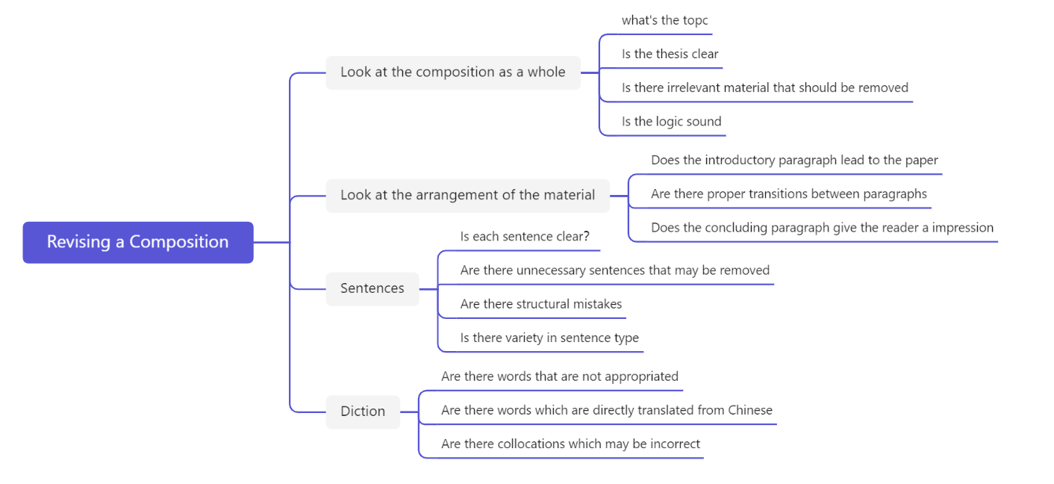
After class:
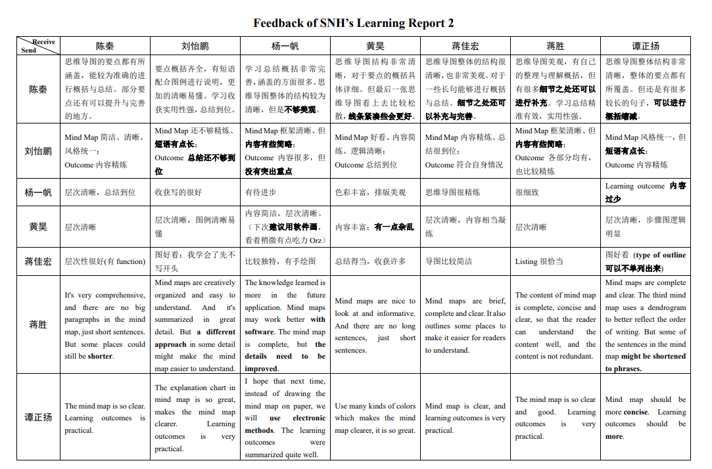
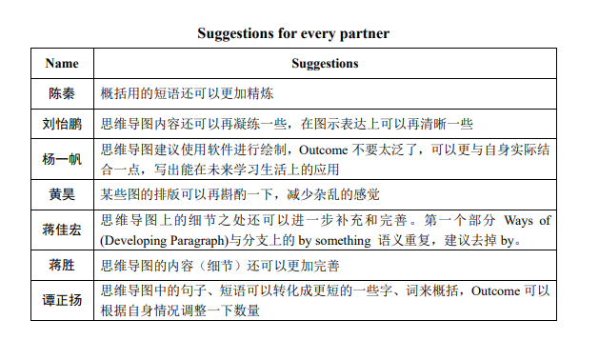
- Learning outcome
To clarify how to complete the study report, it is first necessary to make a more comprehensive evaluation of the homework given to others within the group, including the advantages and disadvantages. Finally, an evaluation of the overall situation of the group is made from a macro perspective. Finally, we can give us where we can still improve.
- My behavior and attitude
1）Out of Class
1.1 Autonomous learning（Online + Offline）
First, a summary and review of last week's assignment completion was carried out. There is a clear understanding of where we can improve. Through MOOCs and teachers' explanations, I have a very clear understanding of the precautions for thesis topic selection.
1.2 Homework
Complete the homework carefully, think carefully about the resaerch methodology parts, and complete them carefully. And submit it in time, without waiting until the deadline to finish.
2)In class
After listening carefully to the teacher's requirements for learning reports, I have a clearer understanding. I can answer questions from the teacher positively.
4．Improvement
I am very familiar with and clear in the writing of the study report, clarify the matters that need to be paid attention to when choosing the topic of my thesis, have a general direction, and know how to query the topics suitable for my investigation.

Week 4
- My learning
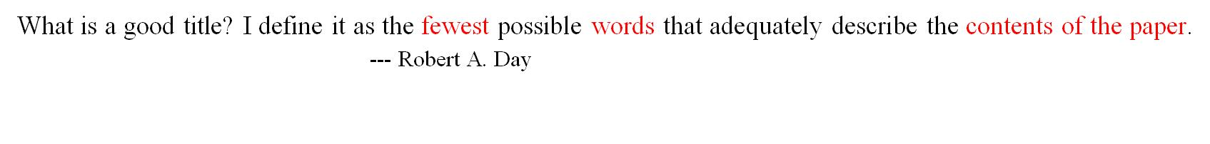
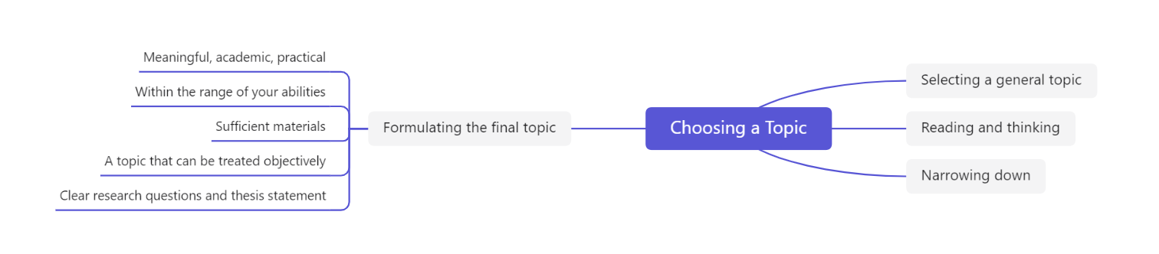
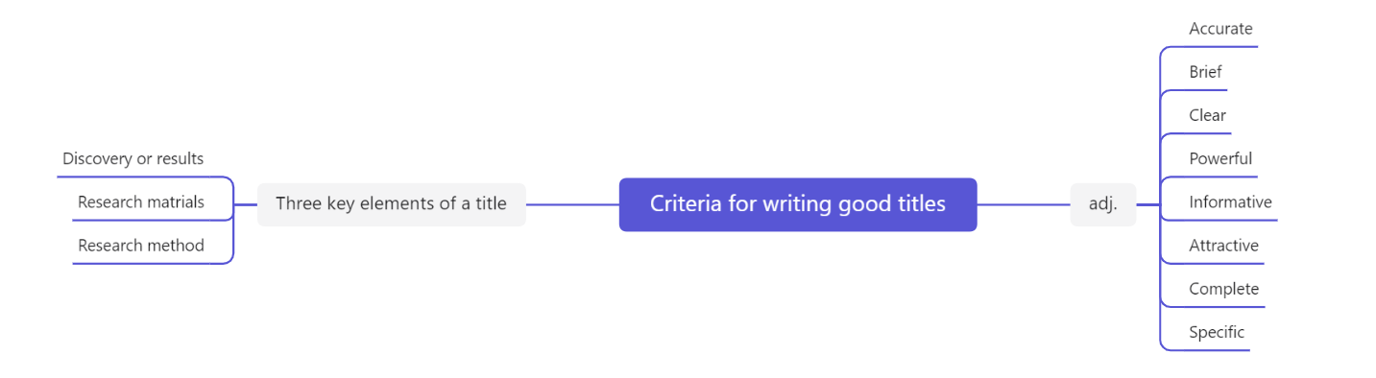
After class:
成员 | 选题 | 重要性 | 必要性 | 研究方法，可行性 | 好处
陈秦 | 大学生转专业选择和应对策略研究 | 大学生转专业选择将深刻影响大学生就业形势，充分的调查研究有助于帮助大学生减轻就业压力。同时，了解大学生转专业趋势有助于高校完善转专业政策，加快新学科新专业建设，帮助大学生减少就业阻力。 | 如果不对大学生转专业选择进行及时调查与研究，高校就无法为大学生转专业提供更好的建议与导向。势必会导致学生盲从，选择不适合自己的专业以及冷门专业人才大量流失。 | 本研究主要通过问卷调查法进行研究，调查主体主要为大学生，调查难度不大，可行性强。  同时，本研究注重于问卷的设计，能够通过调查来反映大学生转专业的意向和选择。 | 帮助高校及时了解学生专业需求，使得高校顺势而为，加快制定政策，优化调整专业设置，帮助学生更好的择业。同时，也可以帮助大学生更好的发挥主观能动性，合理规划理性选择转专业。
After careful consideration, I decided that the topic of my thesis was a major selection strategy for college students. Then determined the importance, necessity, research methodology, feasibility, benefits of my thesis. Then I made a PPT to explain my paper in great detail.
- Learning outcome
Knowing the way to determine the topic of the thesis, I went to many professional paper websites to find many professional papers. Understand some tips for making a proposal report ppt, use very short and condensed words to summarize, do not put a lot of sentences on it. Finally, the text of the opening speech for next week was carefully prepared.
- My behavior and attitude
1）Out of Class
1.1 Autonomous learning（Online + Offline）
I went to many professional paper websites to find many professional papers. Understand some tips for making a proposal report ppt, use very short and condensed words to summarize, do not put a lot of sentences on it. Finally, the text of the opening speech for next week was carefully prepared.
1.2 Homework
Complete the homework carefully, think carefully about the resaerch methodology parts, and complete them carefully. And submit it in time, without waiting until the deadline to finish.
2)In class
I listened carefully to the opening reports of other students and learned some of their PPT production skills. I am not brief enough in the production of PPT, and some key points have not been summarized.
4．Improvement
I have a deeper understanding of the production of PPT, carefully prepared my own thesis opening report, and clarified the significance of my thesis topic

Week 5
- My learning
In class:
参与者 | 评价
明成 | Fluent and no error, brief and complete, clear, with eye contact is better
李佳明 | Fluent and clear, have mind map, specific data, 标题详略不得当
陈慈尹 | Fluent, complete and clear. Flash of PPT deserves improvement
刘江 | Eye contact is good, the structure is clear
田时雨 | Fully prepared, the structure is perfect.
徐聪 | Structure is perfect, fully prepared, but too fast.
王星然 | Fluent and complete, but not brief enough
郑晓涵 | Clear and brief, 目录句子不够统一
刘淑文 | Complete, have survey data
熊皓然 | Colorful picture, have underline, academic
郭传哲 | The key words in the sentence were refined
陈灵彤 | The style is simple, and eye contact can be a little more adequate
吴卓宣 | Clear and logical, have distributed picture
方正 | Structure is clear and have logical order
刘怡鹏 | Rich diagrams, short descriptions
蒋胜 | Very fluent and skilled
谭正扬 | The structure is clear, but there are too many words
After class:
Referring to the template sent by the teacher in the group, the table of contents section of the course paper was designed. At the same time, I watched how to write an introduction part of MOOC scientific research methods and thesis writing, and tried to write the introduction part of my own thesis.

- Learning outcome
Understand the basic structure of the introduction part of the thesis, in order to better write. I also looked at the introduction sections of some excellent papers and also had great gains.
- My behavior and attitude
1）Out of Class
1.1 Autonomous learning（Online + Offline）
After watching MOOCs carefully, I have a detailed understanding of the writing of the introduction part of the paper, and I have a more personal experience of the writing process of the paper by writing my own paper.
1.2 Homework
Complete the homework carefully, think carefully about the resaerch methodology parts, and complete them carefully. And submit it in time, without waiting until the deadline to finish.
2)In class
I listened carefully to the opening reports of other students and learned some of their PPT production skills. I am not brief enough in the production of PPT, and some key points have not been summarized.
4．Improvement
Understand the basic structure of the introduction part of the thesis, in order to better write. I also looked at the introduction sections of some excellent papers and also had great gains. I am not brief enough in the production of PPT, and some key points have not been summarized.

Week 6
- My learning
This week, due to the National Day holiday, there is no classroom learning content.
After class:
Referring to the template sent by the teacher in the group, the table of contents section of the course paper was designed. At the same time, I watched how to write an introduction part of MOOC scientific research methods and thesis writing, and tried to write the introduction part of my own thesis.
- Learning outcome
Understand the basic structure of the introduction part of the thesis, in order to better write. I also looked at the introduction sections of some excellent papers and also had great gains.
- My behavior and attitude
1）Out of Class
1.1 Autonomous learning（Online + Offline）
After watching MOOCs carefully, I have a detailed understanding of the writing of the introduction part of the paper, and I have a more personal experience of the writing process of the paper by writing my own paper.
1.2 Homework
Complete the homework carefully, think carefully about the resaerch methodology parts, and complete them carefully. And submit it in time, without waiting until the deadline to finish.
4．Improvement
Understand the basic structure of the introduction part of the thesis, in order to better write. I also looked at the introduction sections of some excellent papers and also had great gains.

Week 7
- My learning
In class:
Evaluation of the proposal report:
参与者 | 评价
蒋佳宏 | Clear and fluent, there is a very clear theme, Informative
曾欣棋 | The structure is clear, there are fewer errors, and it is better to have eye contact
黄昊 | PPT making is very concise and beautiful, fluent and specific
杨一帆 | The content is substantial and fluent, but there are more PPT words
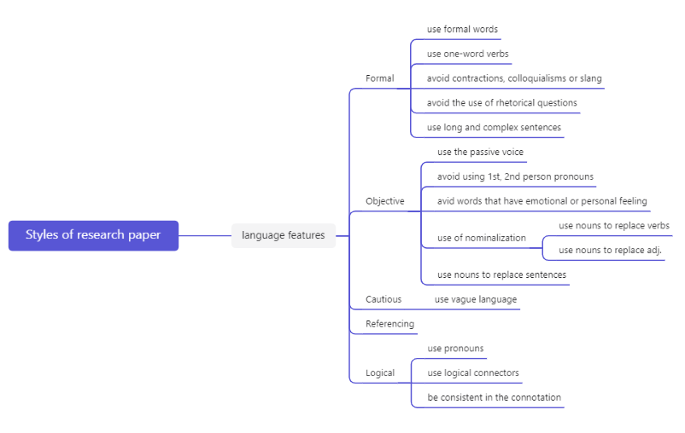
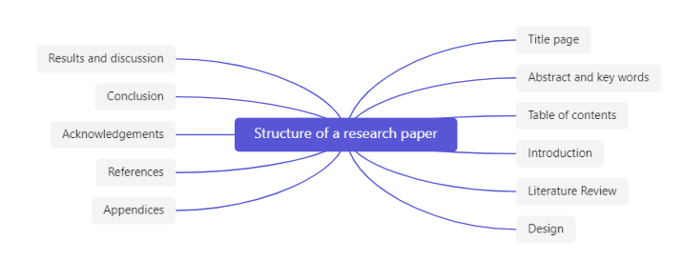
After class:
- First of all, I revised the introduction part of my paper according to the introduction requirements given by the teacher, and found many mistakes that I did not pay attention to when writing at the beginning.
- I consulted the definition of literature review and identified what should be included in literature review. Literature reviews should usually include the background and significance of the research, the explanation of the key concepts in the paper, the current status of research at home and abroad, and the research content and content arrangement of this paper.
- Reviewed literature related to their research topic and completed their own research tools. A questionnaire and interview outline were designed.
- Learning outcome
It clarifies the characteristics of the language that should be used in the paper, and must use accurate and careful language in the scientific research process, and cannot add your own subjective guesses. I made many mistakes by not paying special attention in the introduction part. After learning, I have been able to correct the error correctly and complete the introduction part of a specification. At the same time, I also tried to make my own questionnaire through the questionnaire platform to investigate the problem.
- My behavior and attitude
1）Out of Class
1.1 Autonomous learning（Online + Offline）
The errors in the introduction part of the paper have been carefully corrected, and the sentence specifications in the paper have been further clarified. The questionnaire used in the relevant literature was studied, and combined with the combination, a questionnaire on the topic of his own research was made.f
1.2 Homework
Complete the homework carefully, think carefully about the resaerch methodology parts, and complete them carefully. And submit it in time, without waiting until the deadline to finish.
2）In Class
2.1 Individual performance
Listen carefully to the teacher's explanation of the content of the paper, and record the useful content in time. When the teacher asks questions, actively answer questions in the group and respond to the teacher. Keep thinking about what's relevant.

- Improvement
The errors in the introduction part of the paper have been carefully corrected, and the sentence specifications in the paper have been further clarified. The questionnaire used in the relevant literature was studied, and combined with the combination, a questionnaire on the topic of his own research was made.

Week 8
- My learning
In class:
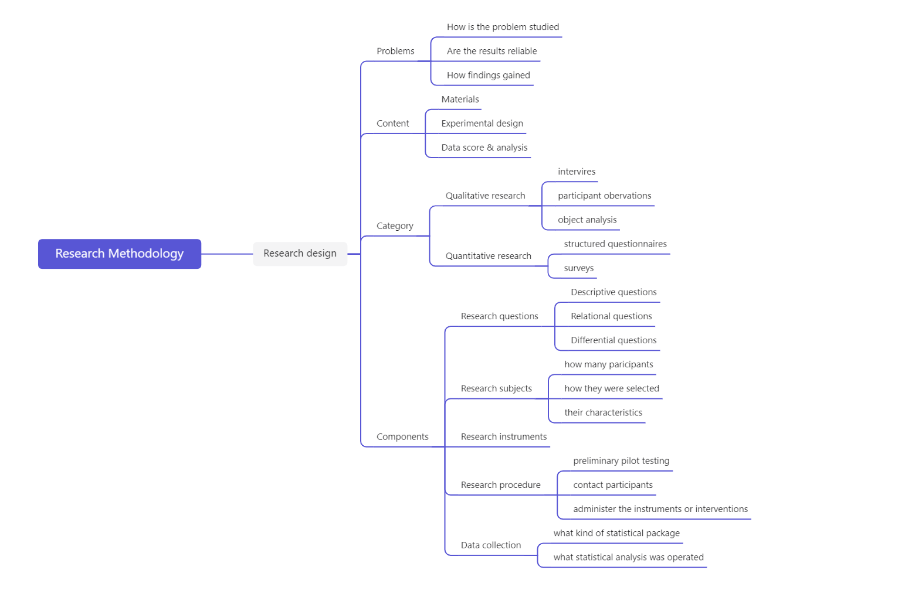
After class:
I learned the main theme of Chapter 19 of the MOOC on Scientific Research Methods and Dissertation Writing: Material and Method Writing. In addition, I completed the second chapter of his thesis, Research Methodology.
- Learning outcome
Through the teacher's explanation of the research methodology and carefully watching the MOOC of Fudan University, I successfully completed the writing of the second chapter of the thesis. The research questions, research objects, tools used in the research, research steps, and data collection are all described in detail and accurately. Through this part of writing, I also have a clearer and more detailed plan for the follow-up research work.
- My behavior and attitude
1）Out of Class
1.1 Autonomous learning（Online + Offline）
After carefully studying the MOOC videos assigned by the teacher, I have a deep understanding of writing of materials and methods, and summarize the knowledge into the formal aspects of mind maps to memorize and view
1.2 Homework
Complete the homework carefully, think carefully about the resaerch methodology parts, and complete them carefully. And submit it in time, without waiting until the deadline to finish.
2）In Class
2.1 Individual performance
Listen carefully to the teacher's explanation of the content of the paper, and record the useful content in time. When the teacher asks questions, actively answer questions in the group and respond to the teacher. Keep thinking about what's relevant.

4．Improvement
I have a very clear understanding of the research methods and materials, and I can write accordingly for my research topic in my paper. In addition, during the course of studying MOOCs, I learned the methods and writing order that other excellent papers are accustomed to using in writing materials. These helped me learn from other excellent experiences and helped refine my thesis.

Week 9
- My learning
Format requirements for the paper：
Under the first-level directory, you can summarize the following.

The questionnaire answers what, the interview answers how and why. Interviews serve as a confirmation and supplement to the questionnaire. Questionnaires do quantitative research, and interviews do quality research.
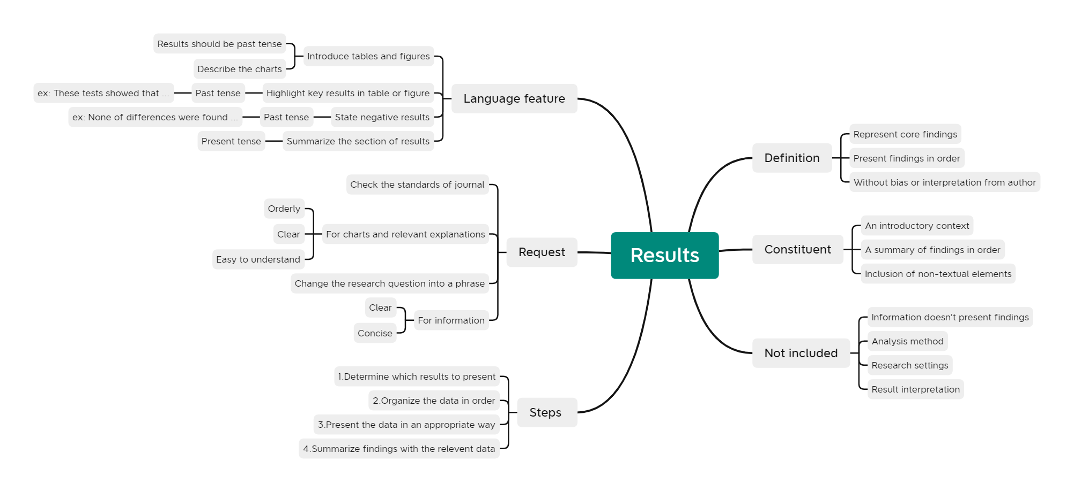
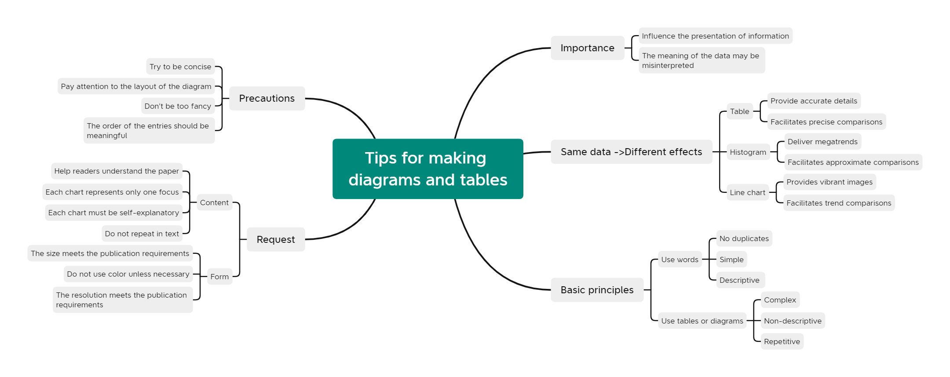
- Learning outcome
This week, under the teacher's emphasis, I have a deeper understanding of the structural requirements of the paper. At the same time, through the MOOC study during and after class, I have a clear understanding of the writing of research results and the production skills of charts and tables. Completed the preliminary knowledge of data analysis. In addition, after class, I also completed the questionnaire research, found many students with the idea of changing majors to conduct research and research, and collected certain data for analysis.
- My behavior and attitude
1）Out of Class
1.1 Autonomous learning（Online + Offline）
After carefully studying the MOOC videos assigned by the teacher, I have a deep understanding of the writing of data analysis and the use of charts, and summarize the knowledge into the formal aspects of mind maps to memorize and view
1.2 Homework
Complete the homework carefully, think carefully about the data analysis parts, and complete them carefully. And submit it in time, without waiting until the deadline to finish
2）In Class
2.1 Individual performance
Listen carefully to the teacher's explanation of the content of the paper, and record the useful content in time. When the teacher asks questions, actively answer questions in the group and respond to the teacher. Keep thinking about what's relevant.
4．Improvement
First of all, the format of the paper clarifies the requirements of the teacher, and the previously completed paper is revised in time. The knowledge related to the description of data and the use of charts was summarized and summarized, and the knowledge of data analysis writing was accumulated.

Week 10
- My learning
In class:
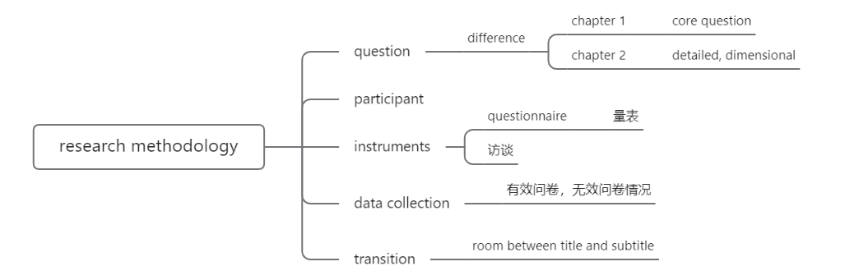
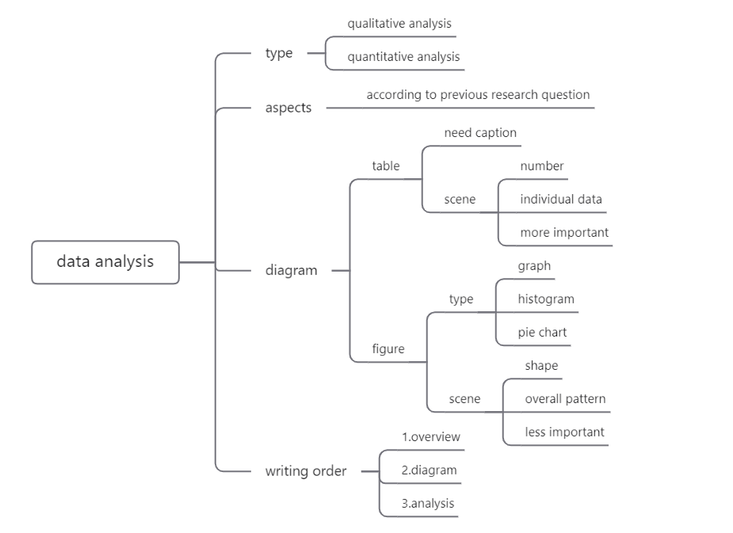

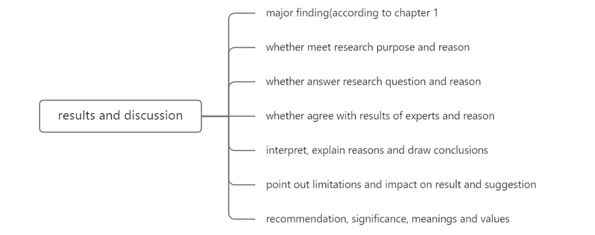
After class:
After the teacher's explanation, I have a certain understanding of how to write data analysis. After the class, I first processed the data from the questionnaire. Use Excel, SPSS and other professional software to analyze the data. Then, combined with the purpose of my investigation, the questions, I analyzed the data and carefully completed this part of the writing.
- Learning outcome
1). During this week's study, I have a clearer understanding of mind map production. You must have your own thinking and summary of the content to be made, reflect the key points in the mind map, and make a certain summary of some relatively long sentences.
2). For the writing of data analysis, we must pay attention to the use of various charts to illustrate the data. At the same time, pay attention to the order of writing, write a summary of the data, give specific icons, and finally analyze accordingly.
- My behavior and attitude
1）Out of Class
1.1 Autonomous learning（Online + Offline）
Go online to find the data analysis modules of relevant papers, observe how excellent papers complete this part, learn and use them.
1.2 Homework
Complete the homework carefully, think carefully about the data analysis parts, and complete them carefully. And submit it in time, without waiting until the deadline to finish
2）In Class
2.1 Individual performance
Listen carefully to the teacher's explanation of the content of the paper, and record the useful content in time. When the teacher asks questions, actively answer questions in the group and respond to the teacher. Keep thinking about what's relevant.
4．Improvement
I have a clearer understanding of the writing of the data analysis part of the paper, and through the in-depth analysis of the topics I investigated, I have become more proficient in using a lot of data analysis software. This has greatly improved me and enabled me to better complete the corresponding tasks in my future research work. At the same time, the understanding of mind maps is clearer.

Week 11
- My learning
In class:
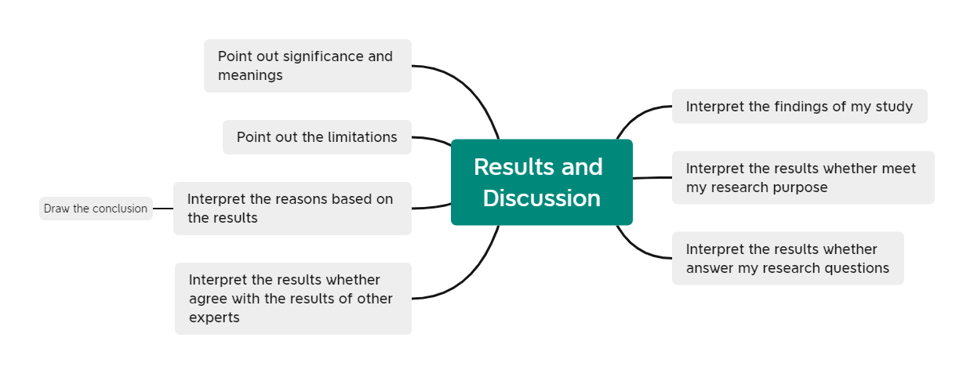
Recommended language in results and discussion：
The most important discovery in this research is
The findings of this research in agreement with…
The current findings expand the prior work…
Summary how data analysis is done:
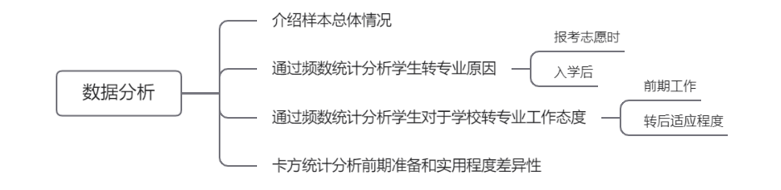
After class:
According to the content of the teacher's lecture, carefully complete the writing of the results and discussion parts of the paper and submit them in time.
- Learning outcome
When writing results versus discussion, you can start by summarizing the results of the research. Then explore whether the research results meet their own research objectives, answer their own research questions, and whether the results of experts are consistent. Finally, a summary can be made.
In addition, I also learned that when the teacher assigns a presentation task, it is best to make a PPT or mind map for display, which is more intuitive.
- My behavior and attitude
1）Out of Class
1.1 Autonomous learning（Online + Offline）
Go online to find the results and discussion modules of relevant papers, observe how excellent papers complete this part, learn and use them.
1.2 Homework
Complete the homework carefully, think carefully about the results and discussion parts, and complete them carefully. And submit it in time, without waiting until the deadline to finish
2）In Class
2.1 Individual performance
Listen carefully to the teacher's explanation of the content of the paper, and record the useful content in time. When the teacher asks questions, actively answer questions in the group and respond to the teacher. Keep thinking about what's relevant.
2.2 Cooperation
Learn how others report and strive to apply it to your own report next time.
4．Improvement
Learn more about the writing of the results and discussion sections in the paper. Identified areas for improvement in class presentation.

Week 12
- My learning
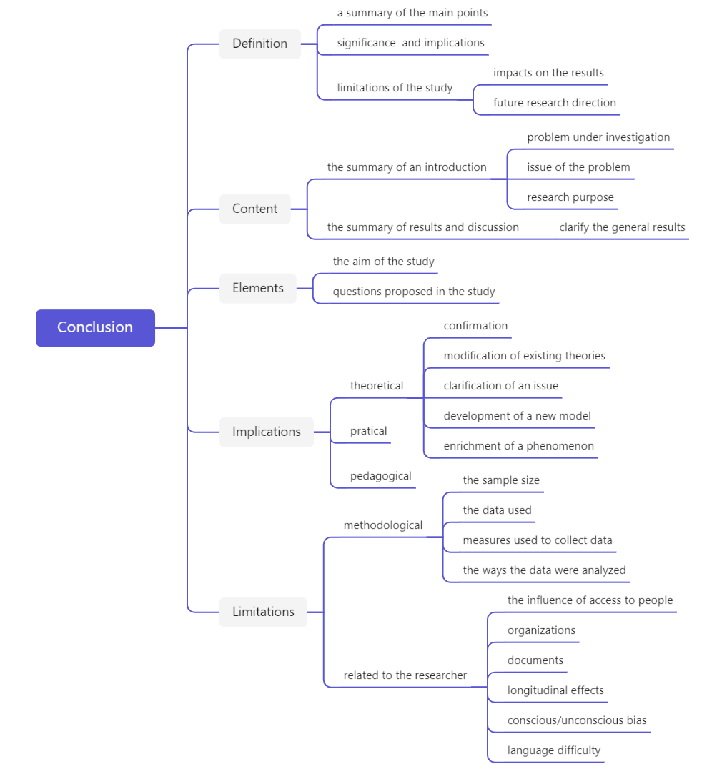
Useful expressions for restating the research purpose:
- This research investigated…
- This paper has given an account of…
- The main point of this essay has been…
- The purpose of the study was to…
- The present study was to determine…
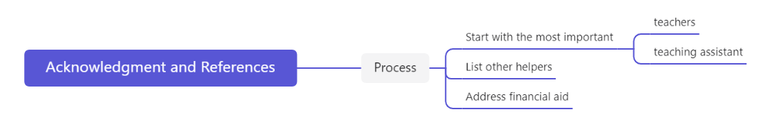
- Learning outcome
Understand the writing requirements for the summary section and the acknowledgement section in academic essay writing. In particular, I learned some expressions that are often used. In addition, I put it into practice and tried to write based on the survey of changing majors.
- My behavior and attitude
1）Out of Class
1.1 Autonomous learning（Online + Offline）
Go online to find the conclusion and acknowledgements modules of relevant papers, observe how excellent papers complete this part, learn and use them.
1.2 Homework
Complete the homework carefully, think carefully about the results and discussion parts, and complete them carefully. And submit it in time, without waiting until the deadline to finish
2）In Class
2.1 Individual performance
Listen carefully to the teacher's explanation of the content of the paper, and record the useful content in time. When the teacher asks questions, actively answer questions in the group and respond to the teacher. Keep thinking about what's relevant.
4．Improvement
I wrote the summary part and the acknowledgments part of the paper, and carefully completed the relevant homework.

Week 13
- My learning
In class:
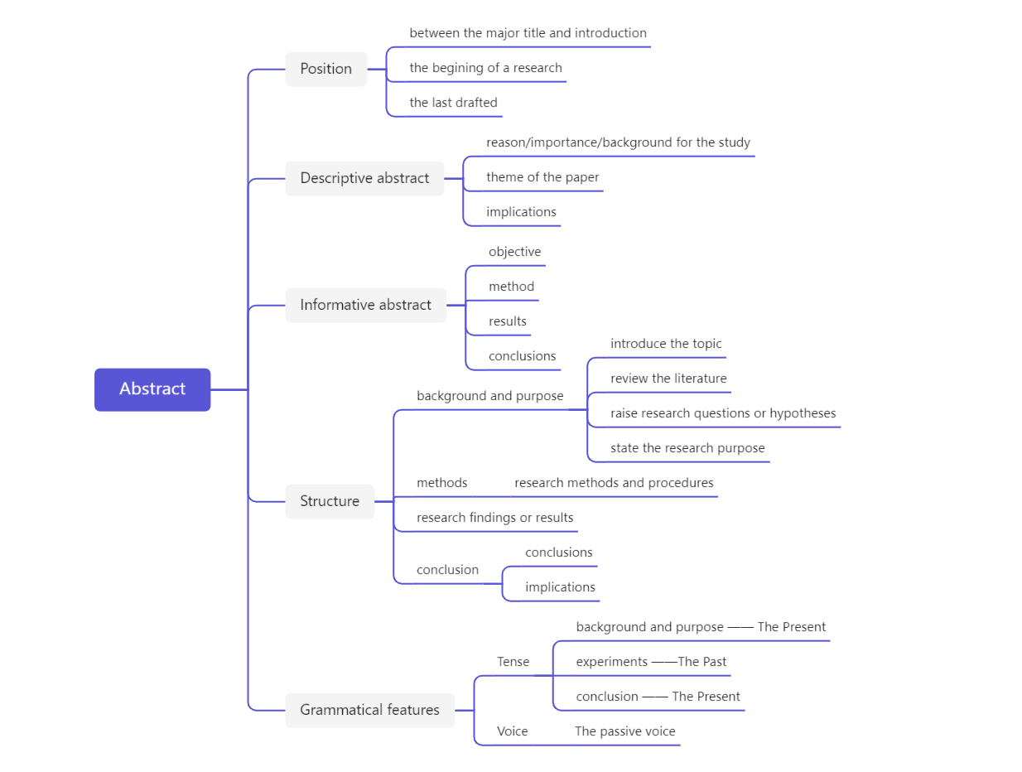

- Learning outcome
（本周课内外学到了/学成了什么，列举哪些知识在未来的学习或者工作中如何使用。比如：当老师讲了如何做presentation之后，就可以列举出：1）When giving oral presentation，pay attention to the interaction with audience and PPT. 2）When giving oral presentation，think of the structure of my speech，such as Gold Circle，PREP.)
- My behavior and attitude (我课内外的表现与态度)
4．Improvement
第3和第4点可以从以下方面去考虑：
1）Out of Class
1.1 Autonomous learning（Online + Offline）
1.1.1 Online（MOOC or other platform online）
1.1.2 Offline（listening, speaking, reading, writing, translation）
1.2 Homework (on time; not leave your homework until deadline; serious attitude)
1.3 Cooperative learning（group discussion，making PPT，as a group leader，etc.）
2）In Class
2.1 Individual performance (Concentration, taking notes, questions and answers, comments).
2.3 Cooperation (Classroom discussion, Classroom presentation and performance)

Week 1
- My learning
(本周课内外学了什么，建议以思维导图形式归纳和总结)
- Learning outcome
（本周课内外学到了/学成了什么，列举哪些知识在未来的学习或者工作中如何使用。比如：当老师讲了如何做presentation之后，就可以列举出：1）When giving oral presentation，pay attention to the interaction with audience and PPT. 2）When giving oral presentation，think of the structure of my speech，such as Gold Circle，PREP.)
- My behavior and attitude (我课内外的表现与态度)
4．Improvement
第3和第4点可以从以下方面去考虑：
1）Out of Class
1.1 Autonomous learning（Online + Offline）
1.1.1 Online（MOOC or other platform online）
1.1.2 Offline（listening, speaking, reading, writing, translation）
1.2 Homework (on time; not leave your homework until deadline; serious attitude)
1.3 Cooperative learning（group discussion，making PPT，as a group leader，etc.）
2）In Class
2.1 Individual performance (Concentration, taking notes, questions and answers, comments).
2.3 Cooperation (Classroom discussion, Classroom presentation and performance)

